**SQL QUERIES:**

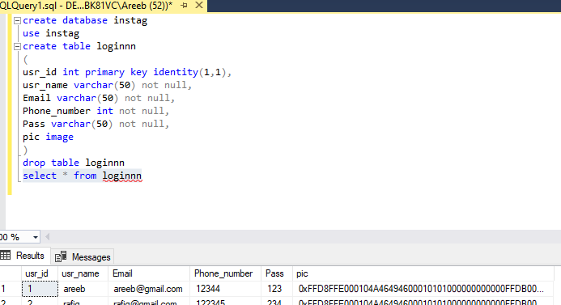

**SQL CONNECTION:**

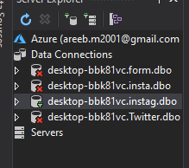

**VISUAL STUDIO:**

**APP.CONFIG:**

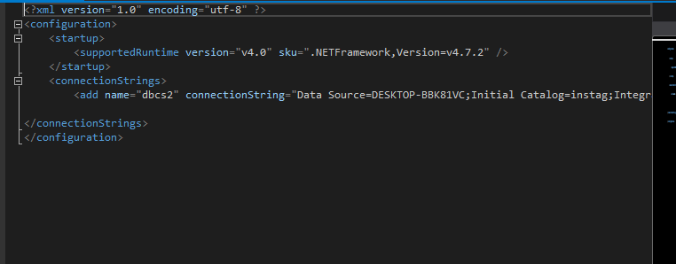

**SIGNUP :**

**CODE:**

using System;

using System.Collections.Generic;

using System.ComponentModel;

using System.Data;

using System.Drawing;

using System.Linq;

using System.Text;

using System.Threading.Tasks;

using System.Windows.Forms;

using System.Data.SqlClient;

using System.Configuration;

using System.IO;

namespace Instagram

{

public partial class Signup : Form

{

public Signup()

{

InitializeComponent();

}

string cs = ConfigurationManager.ConnectionStrings["dbcs2"].ConnectionString;

private void button1_Click(object sender, EventArgs e)

{

SqlConnection con = new SqlConnection(cs);

if (text1.Text != "" && text2.Text != "" && text3.Text != "" && text4.Text != "")

{

SqlCommand cmd = new SqlCommand("insert into loginnn values(@usr_name,@Email,@Phone_number,@Pass,@pic)", con); ;

cmd.Parameters.AddWithValue("@usr_name", text1.Text);

cmd.Parameters.AddWithValue("@Email", text2.Text);

cmd.Parameters.AddWithValue("@Phone_number", text3.Text);

cmd.Parameters.AddWithValue("@Pass", text4.Text);

cmd.Parameters.AddWithValue("@pic", SavePicture());

con.Open();

cmd.ExecuteNonQuery();

con.Close();

MessageBox.Show("Account Created", "Record Added", MessageBoxButtons.OK, MessageBoxIcon.Information);

clear();

Login l1 = new Login();

l1.Show();

this.Hide();

}

else

{

MessageBox.Show("Field Required", "Error", MessageBoxButtons.OK, MessageBoxIcon.Error);

}

}

public void clear()

{

text1.Clear();

text2.Clear();

text3.Clear();

text4.Clear();

}

private void button2_Click(object sender, EventArgs e)

{

Application.Exit();

}

private void button3_Click_1(object sender, EventArgs e)

{

Login l2 = new Login();

l2.Show();

this.Hide();

}

private void button4_Click(object sender, EventArgs e)

{

OpenFileDialog ofd = new OpenFileDialog();

ofd.Title = "Select Image";

ofd.Filter = "Image Files(*.BMP;*.JPG;*.GIF)|*.BMP;*.JPG;*.GIF|All files (*.*)|*.*";

if (ofd.ShowDialog() == DialogResult.OK)

{

pictureBox1.Image = new Bitmap(ofd.FileName);

}

}

private byte[] SavePicture()

{

MemoryStream ms = new MemoryStream();

pictureBox1.Image.Save(ms, pictureBox1.Image.RawFormat);

return ms.GetBuffer();

}

private void Signup_Load(object sender, EventArgs e)

{

}

}

}

**OUTPUT:**

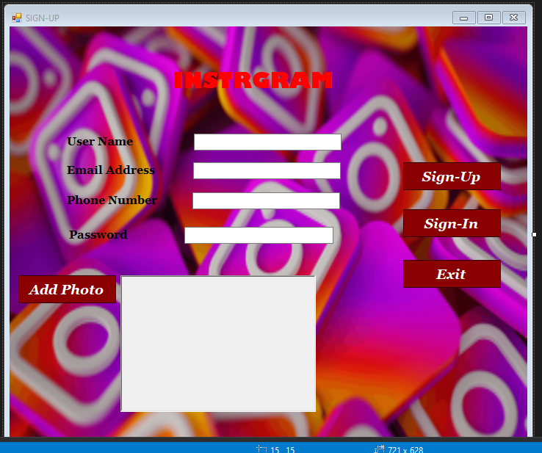

**LOGIN:**

**CODE:**

using System;

using System.Data;

using System.Drawing;

using System.Windows.Forms;

using System.Data.SqlClient;

using System.IO;

using System.Configuration;

namespace Instagram

{

public partial class Login : Form

{

public Login()

{

InitializeComponent();

}

string cs = ConfigurationManager.ConnectionStrings["dbcs2"].ConnectionString;

private void button1_Click(object sender, EventArgs e)

{

SqlConnection connect = new SqlConnection(cs);

if (textBox2.Text != "" && textBox4.Text != "")

{

SqlDataAdapter adapt = new SqlDataAdapter(@"select * from loginnn

where Email = '" + textBox2.Text + "' and Pass = '" + textBox4.Text + "'", connect);

DataTable dt = new DataTable();

info in1 = new info();

adapt.Fill(dt);

adapt.Fill(in1.dt2);

connect.Open();

if (dt.Rows.Count > 0)

{

MessageBox.Show("Logged In", "Information", MessageBoxButtons.OK, MessageBoxIcon.Information);

in1.Show();

this.Hide();

}

else

{

MessageBox.Show("Invalid Email or Password", "Error", MessageBoxButtons.OK, MessageBoxIcon.Error);

}

}

connect.Close();

}

public void clear() {

textBox2.Clear();

textBox4.Clear();

}

private void button2_Click(object sender, EventArgs e)

{

Signup s1 = new Signup();

s1.Show();

this.Hide();

}

private void Login_Load(object sender, EventArgs e)

{

}

}

}

**OUTPUT:**

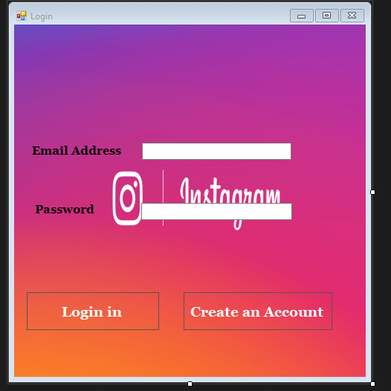

**INFO:**

**CODE:**

using System;

using System.Collections.Generic;

using System.ComponentModel;

using System.Data;

using System.Drawing;

using System.Linq;

using System.Text;

using System.Threading.Tasks;

using System.Windows.Forms;

using System.Data.SqlClient;

using System.Configuration;

using System.IO;

namespace Instagram

{

public partial class info : Form

{

public info()

{

InitializeComponent();

}

private void label2_Click(object sender, EventArgs e)

{

}

public DataTable dt2 = new DataTable();

private void User_Info_Load(object sender, EventArgs e)

{

foreach (DataRow dr in dt2.Rows)

{

name.Text = dr["usr_name"].ToString();

email.Text = dr["Email"].ToString();

num.Text = dr["Phone_number"].ToString();

pass.Text = dr["Pass"].ToString();

pictureBox1.Image = GetPhoto((byte[])dr["pic"]);

}

}

private Image GetPhoto(byte[] photo)

{

MemoryStream ms = new MemoryStream(photo);

return Image.FromStream(ms);

}

}

}

**OUTPUT:**

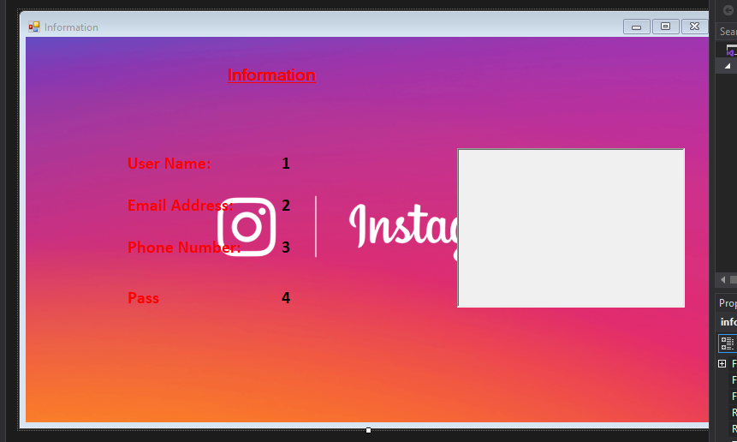

**RUN:**

